Supplementary Figures S1 and S2

Title: Unique sex chromosome translocations and evolutionary strata in two Sylvioidea songbird families
Authors: Thomas Brown, Simon Jacobsen Ellerstrand, Hanna Sigeman, Martim Melo, Max Lundberg, Bengt Hansson

Figure S1

A) Nicator vireo
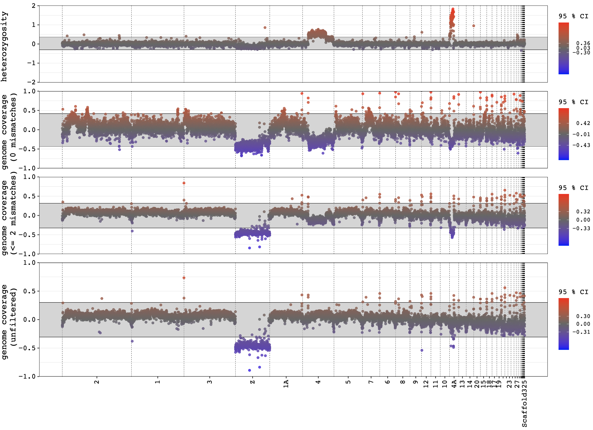
B) Camaroptera brevicaudata
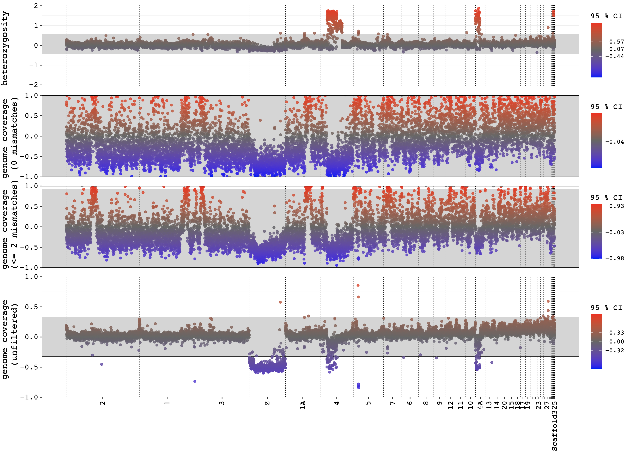
C) Cisticola juncidis
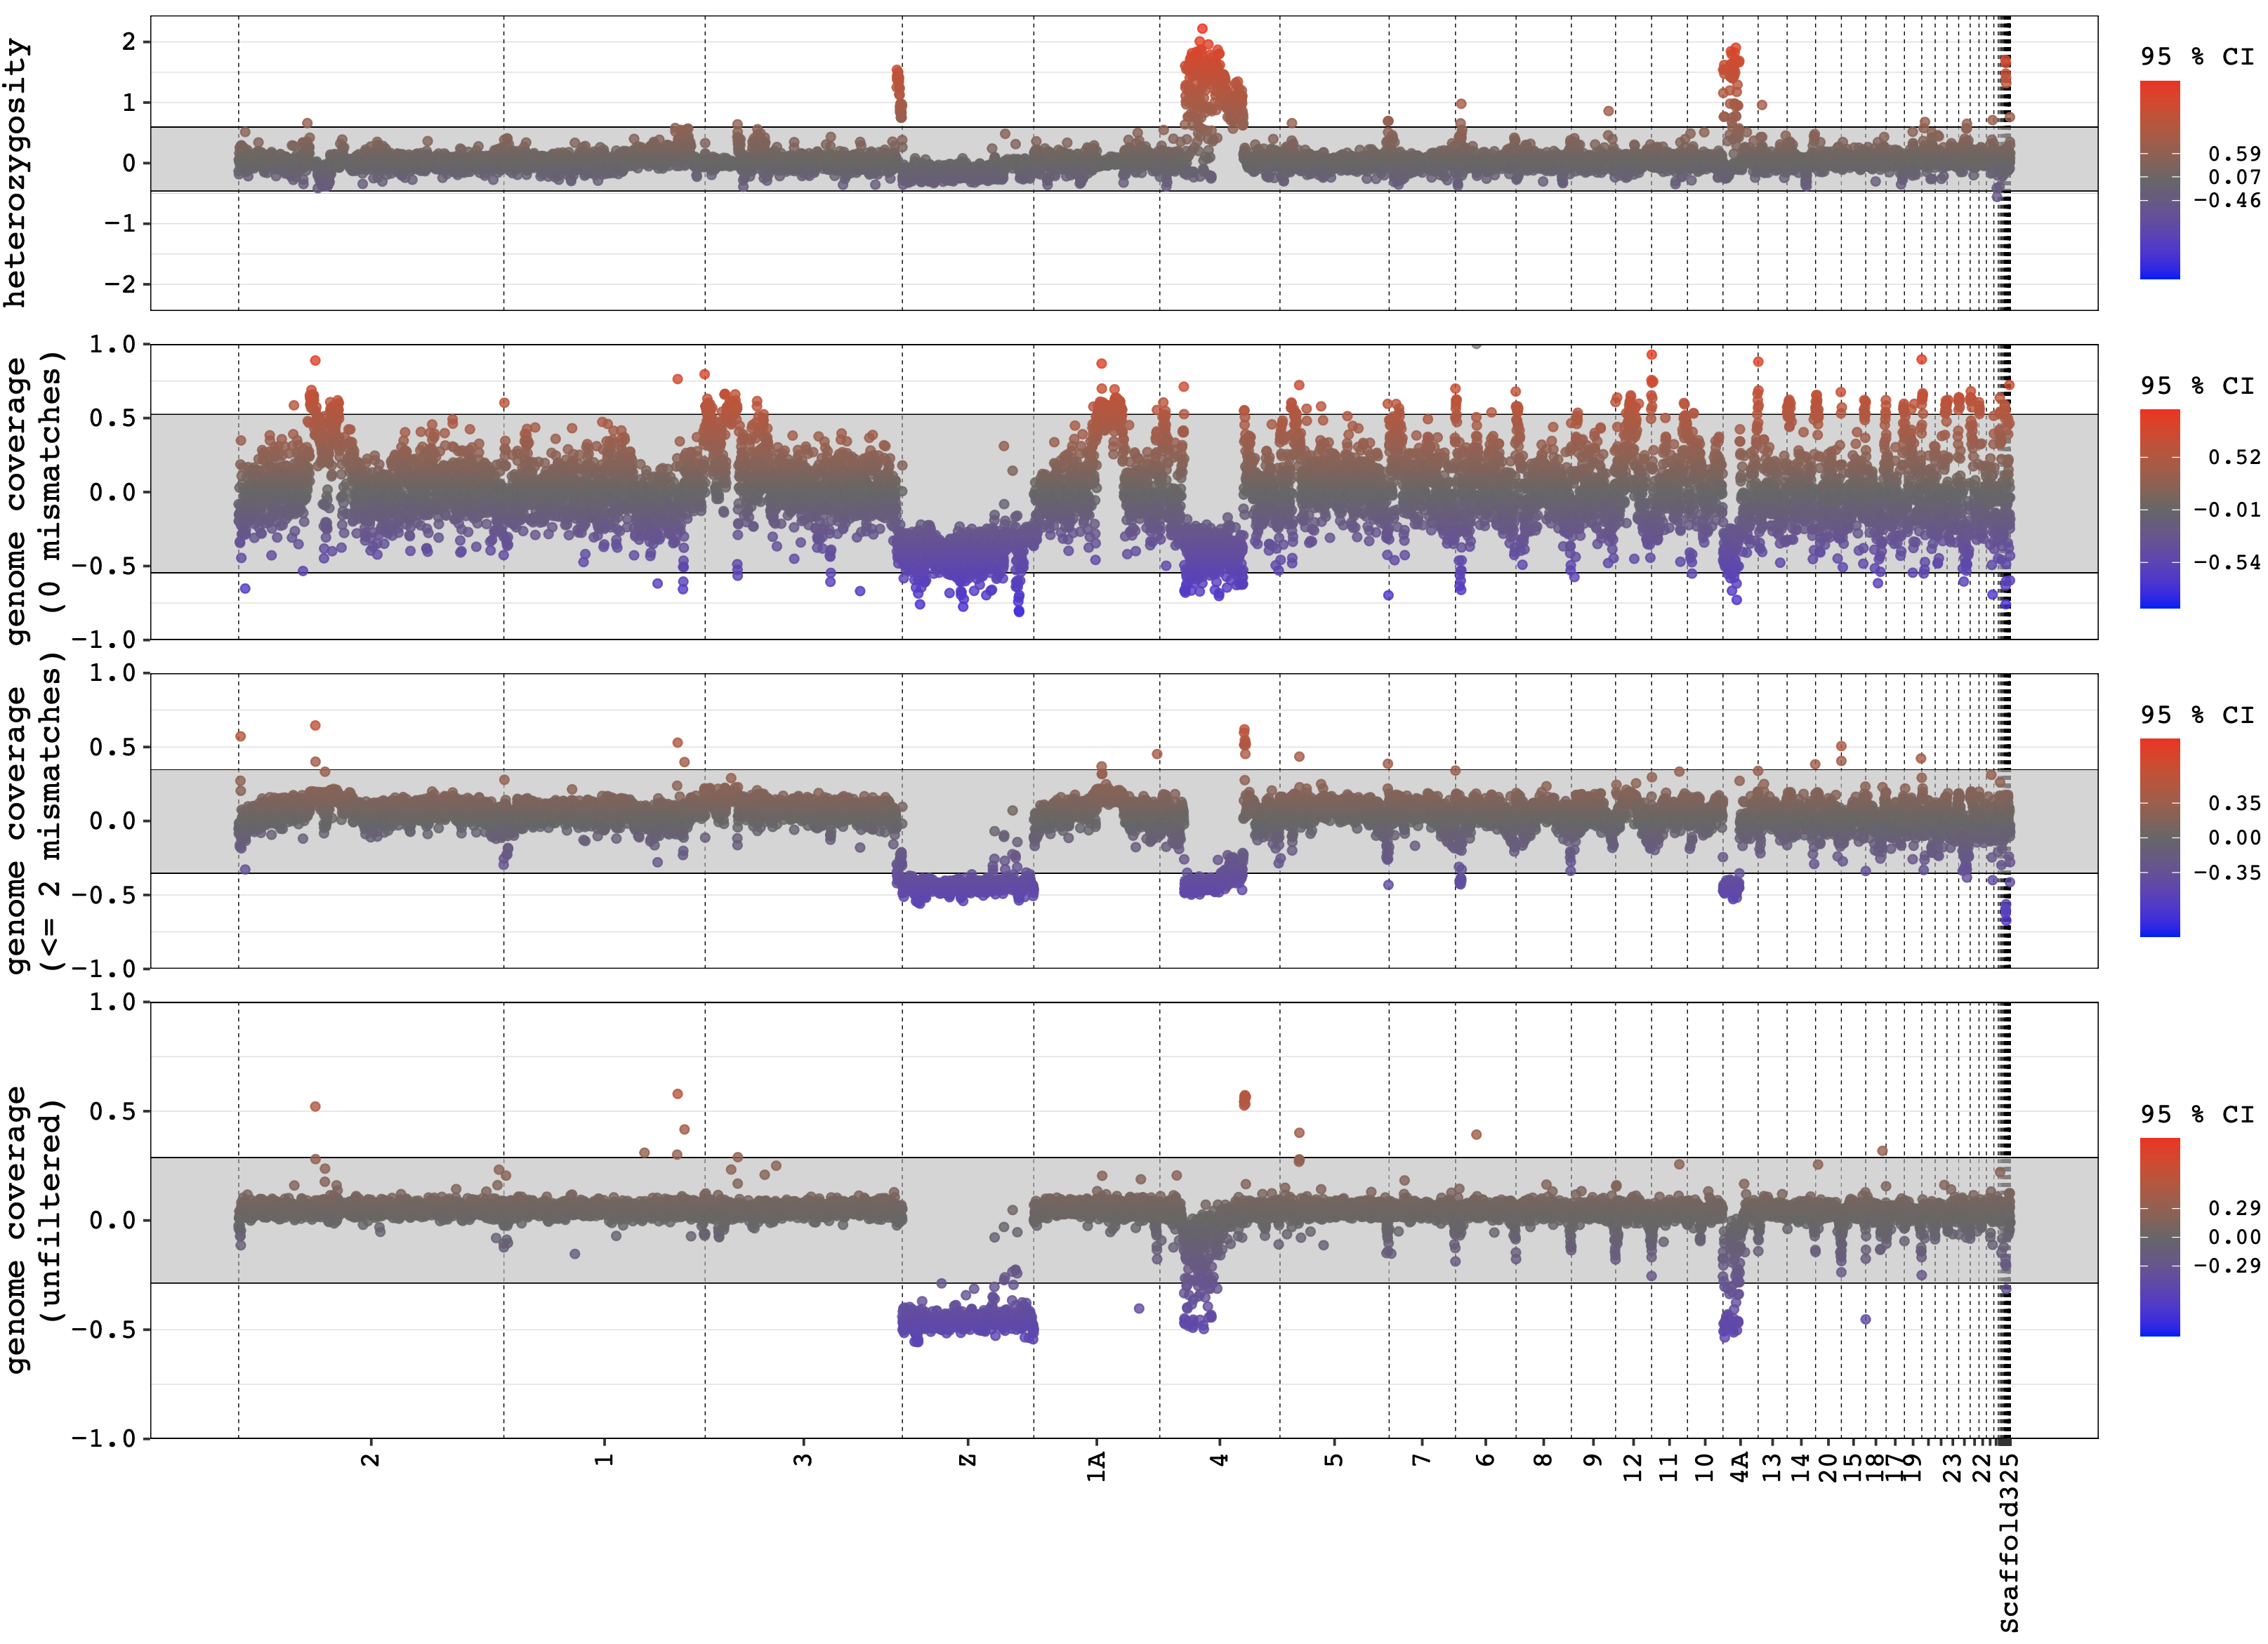
Figure S1. Female-to-male difference in heterozygosity and sequencing depth (genome coverage) across Parus major chromosomes (numbered accordingly) in 100 kb windows for (A) Nicator vireo, (B) Camaroptera brevicaudatus and (C) Cisticola juncidis. Sequencing depth is based on data of three different read mismatch criteria (see main text for details).

Figure S2

A) Nicator vireo
B) Camaroptera brevicaudata
C) Cisticola juncidis
Figure S2. Heterozygosity and sequencing depth (genome coverage) in males (homogametic; ZZ) and females (heterogametic; ZW) across Parus major chromosomes (numbered accordingly) in 1 Mb windows for (A) Nicator vireo, (B) Camaroptera brevicaudatus and (C) Cisticola juncidis. Sequencing depth is based on data of three different read mismatch criteria (see main text for details).

